
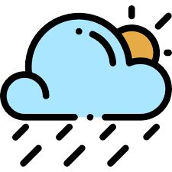
Certificate of Participation

This certificate is proudly presented to
[Student Name]
for outstanding participation as a Meteorologist in the exciting weather simulation Storm-e at Weather Central.

You helped analyze air pressure, humidity, temperature, and wind data to make important decisions about outdoor events just like real meteorologists do!

Congratulations on becoming a Weather Expert!
Date: Teacher:

_________________________________ _____________________________________

